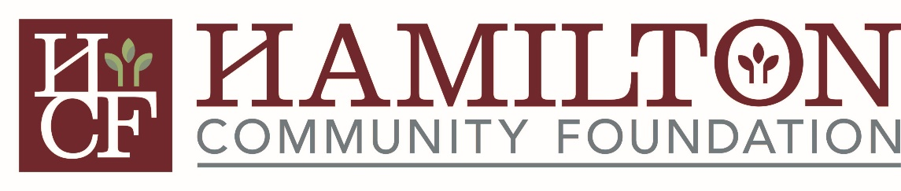
HAMILTON COMMUNITY FOUNDATION
WOMEN IN PHILANTHROPY

PROGRAM OVERVIEW

MISSION STATEMENT
HCF Women in Philanthropy unites women in Hamilton County to inspire and promote philanthropy by working collaboratively to cultivate a strong, vibrant community.

Community members who join HCF Women in Philanthropy (WIP) are an important part of a group that brings together and leverages the power of women interested in philanthropy, their community and maximizing impact through collective giving and grant making. Each member is committed to leaving a footprint in Hamilton County that has the power to transform lives and impact the community we live in. The purpose of this program is to educate, inspire and empower women to become confident and engaged stakeholders at every stage of the philanthropic journey while connecting them to the needs of the community and the organizations addressing those needs.

Women are a powerful force and are passionate about changing their communities for the better. Today, women make up 53% of the workforce, constitute 27% of business owners, and are starting new businesses at three times the rate of men. More women than men are graduating from college, and women are increasingly moving into higher-paying professional and management careers.

The HCF Women in Philanthropy Program is a group of powerful women that engage in programs to enhance their knowledge of philanthropy and participate in the grantmaking and cultivation process. WIP strives to achieve various goals that encourage philanthropy through a program that encompasses:
- educational presentations that empower women;
- grantmaking efforts that are responsive to community needs;
- role modeling and mentoring of high school juniors and seniors through the Three Pillars Initiative philanthropy program; and
- identifying community opportunities for the betterment of Hamilton County.

Membership gifts: Anyone interested in HCF WIP may join with a minimum annual contribution of $200. All membership contributions are put into the HCF WIP Fund to be used for WIP grantmaking. Members joining in the second half of a calendar year are asked to make a short-year gift of at least $100 to attain membership status.

Meetings: In a typical year, HCF WIP will meet six to eight times, including a kickoff luncheon and wrap-up meeting, as well as four to five grant presentations or site visits in the Hamilton County area. Informational presentations will provide an opportunity for members to become educated on how to strategically evaluate an organization, including a review of financial documents and organizational structure, and to hear from a community expert on the overarching focus of the grantmaking process. This strengthens HCF WIP’s process of awarding grants to vetted community organizations and projects, and provides tools for the member’s individual and collective philanthropy.

Annually, the group votes on projects that will receive grants from the HCF WIP Fund held at the Hamilton Community Foundation. Grant money is raised through membership contributions and potentially matched with additional grant funds at the Foundation.

Committees within WIP

Education Committee
- Promotes awareness and understanding of the Hamilton County nonprofit community
- Identifies and recruits a keynote speaker for the annual HCF WIP Grant Awards Celebration
- Promotes skill-building and informational programming related to philanthropy, grantmaking and collective giving
- Mentor and deliver the Three Pillars Initiative Philanthropy Program to high school juniors and seniors. This is a two year program that includes five hours of training and four to six hours per month during the school year.

Grant Committee
- Help inform organizations and Hamilton County entities about HCF WIP’s grant program
- Accept and review letters of inquiry from organizations and Hamilton County entities
- Invite selected applicants to submit grant proposals
- Review proposals and select projects advancing to grant presentations and/or site visits
- Inform members about the projects and determine project finalists to be included for ballot selection
- Evaluate and improve the grants process after each grant cycle

Membership Committee
- Promote HCF WIP through social gatherings and networking opportunities
- Plan new member recruitment events and activities throughout the year
- Facilitate new member orientation
- Work with the Education Committee to develop programs that engage and educate members and guests
- Reach out to current members to encourage their continuing participation in HCF WIP

Never doubt that a small group of thoughtful, committed citizens can change the world.
Indeed, it is the only thing that ever has. ~ Margaret Mead

